Conditional probability

: Probability of  given 

Probability of  conditioned on 







Bays Theorem



**Sequential experiment and Tree diagrams**

Ex 1.27] Suppose you have two coins, one biased, one fair, but you don’t know which coin is which. Coin 1 is biased. It comes up head with probability while coin 2 will flip with equal probability. Suppose you pick a coin at random with equal probability. Let  denote the event that coin  is picked.

1. Find probability of  given that outcome is head, ?
2. ?







































1.8 **Counting methods**

1. **Order considered with sample replacement** (considering  samples out of total  samples) – each object can be chosen repeatedly

* The total # of possibilities = 

Ex] Binary sequence of 10 bits = 

1. **Order considered without sample replacement**

The total # of possibilities = The number of  permutation of  distinguishable objects

=>

1. **Order not considered without sample replacement** (The number of ways to choose  objects out of  distinguishable objects)

or **binomial coefficients**

 combination or  choose  = 

For  repetitions of a sub experiment with sample space , the number of length  observation sequences with  appearing  times is



**Ex]** # possibilities of five-card poker hands is



**Ex]** A baseball team has 15 field players and 10 pitchers. Each field player can take any of the 8 non-pitching positions.

1. What is the number of possible starting lineup (8 field player + 1 pitcher)?

For each choice of starting lineup, the manager needs to submit to the umpire a batting order for the 9 starters

2. What is the possible batting order?

1.

1. Choose 1 pitcher out of 10 = 
2. Choose 8 field player out of 15 = 
3. the number of possible starting lineup (9 people)



2.

64,350 x 9! = 23,351,328,000 🡨(We need to consider the order.)

**Quiz 1.8]** Consider a binary code with 4 bits (0 or 1) in each code word. An example of a code word is 0110.

1. How many different code words are there?
2. How many code words have exactly two zeros?
3. How many code words begin with zeros?
4. In a constant-ratio binary code, each code word has N bits. In every word, M of the N bits are 1 and the other N-M bits are 0. How many different code word are in the code with N=8 and M=3?

|  |  |
| --- | --- |
| 1 |  |
| 2 |  |
| 3 | =8 |
| 4 |  |

The **probability** of  failures and  successes in  independent trials is



Ex 1.40]. We found that a randomly tested resistor was acceptable with probability. If we randomly test 100 resistors, what is the probability of , the event that  resistors test acceptable?



A sub-experiment has sample space  with. For  independent trials, the probability of  occurrences of , , is



Ex) What is the **probability** of exactly 47 heads in 100 flips of a *fair* coin?

[47 heads] = 

=  = 0.066

**Ex 1.42]** Each call arriving at a telephone switch is independently either a voice call with probability 7/10, a fax call with probability 2/10, or a modem call with probability 1/10. Let  denote the event that we observe  voice calls,  fax calls, and  modem calls out of 100 observed calls. What is the **probability** of , ?



**1.10 Reliability Problems**

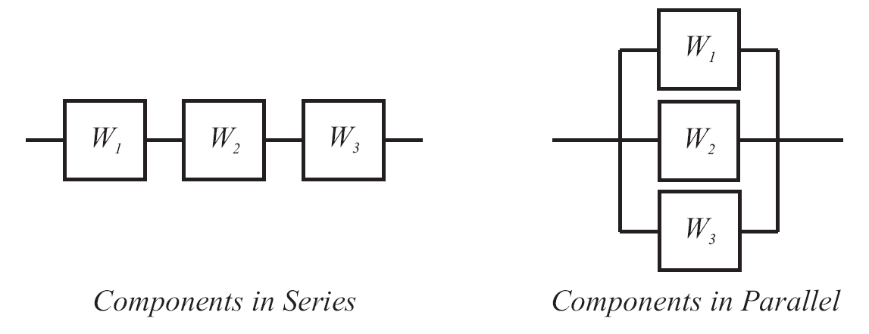

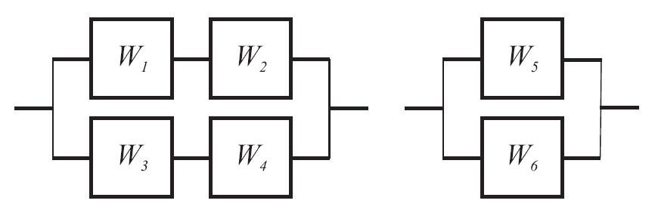

Independent trials with each components succeeds with probability 



Components in *serial*: The operation succeeds if all of its components succeed.

P[operation succeeds] = 

Components in *parallel*: The operation succeeds if any components work.

P[operation succeeds] = 1 – 

Quiz 1.10

A memory module consists of nine chips. The device is designed with redundancy so that it works even if one of its chips is defective. Each chip contains  transistors and functions properly if all of its transistors work. A transistor works with probability  independent of any other transistor.

1. What is the probability  that a chip works?
2. What is the probability  that memory module works?





Midterm question

**1**

**2**

**a1**

**a3**

**a2**

**a4**

**3**

In the switching circuit shown above, the switches a1, a2, a3, and a4 are open or closed at random and independently. The probability that any switch is closed at a given time equals. What is the probability that at any given time there is at least one closed path from 1 to 2?

Let’s think from 1 to 3 first.

The problem state that “at least one closed path” so it might be good idea to start with all open path first and subtract from 1. In other words,







so,



Now the total closed path from 1 to 2 is

